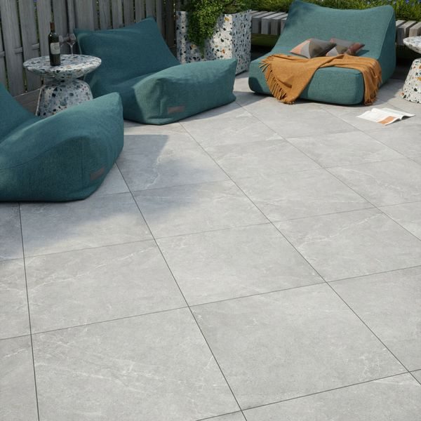**Clifton Grey 60x60 20mm Porcelain Paving Slabs:**

## **Product Description**

Make your outdoor space one of gorgeous design with these Clifton Grey 60x60 20mm Slab Tiles. They feature a realistic stone effect design but are crafted from durable porcelain for quality tiles that are bound to last. Create that patio space you've always dreamed of!

**What's special about these tiles?**

> Authentic, textured design

> Realistic stone effect look

> 20mm thick porcelain for weather resistance and durability

> Anti-slip, matt finish

> Perfect for seamless living

**The perfect finishing touch**

For that perfect finish around your patio space, line the edges with our stylish new [20mm Paving Slab Trims!](https://www.wallsandfloors.co.uk/20mm-paving-slab-trims) Choose the colour that best matches your style!

## **Product INFO**

* Product ID: 44824
* Tiles Per SQM: 2.8246592754749
* Sale by: Per SQM
* Size: 595x595x20mm
* Weight: 13.70 KG
* Material Type: Porcelain
* Finish: Matt
* Colour: Grey
* Suitability: Floors
* Area Of Usage: External
* Grade: 4
* Rectified Edge: Yes
* Underfloor Heating: Yes
* Anti Slip Grade: R11 / 35 Degrees
* Document: [20mm Installation Guide](https://m2.wallsandfloors.co.uk/media/amasty/amfile/attach/20mm-installation-guide_4.pdf),[Cleaning and Protection Guide](https://m2.wallsandfloors.co.uk/media/amasty/amfile/attach/ltp_-_walls_floors_-_external_porcelain_-_cleaning_and_protection_guide_-_april_2020.pdf)
* Thickness (mm): 20